Identifying skill gaps using a skills matrix

A skills matrix is a way of finding skills gaps across a business and can be easily created in a spreadsheet, or by hand. It's also a great way to manage sickness and holiday leave, making sure you have the relevant skills to plan for staff cover.

How to do a skills matrix
- List out the relevant members of staff in the rows - it may help to only focus on one department at a time
- List out key skills needed within the department to help it succeed and grow in the columns - you may find it helpful to separate key skills into categories (e.g. safety and customer service in the example below). Key skills can be anything from active listening skills to First Aid training.
- Identify which members of staff are trained in which areas by marking the relevant rows and columns. For personal skills you may find it useful to take a ranking system approach by scoring each person between 1 and 5 for their expertise.
- The resulting table shows which staff could benefit from training in which areas, and where there are gaps in key skills.
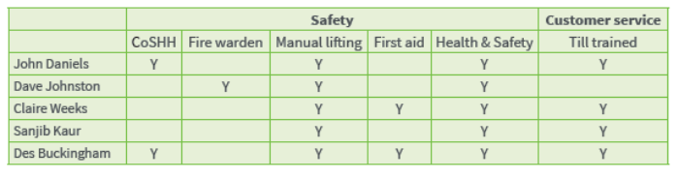

An example skills matrix

You can find more information and examples here:
http://www.managersresourcehandbook.com/skills-matrix-template/
https://www.thoughtfulleader.com/skills-matrix/

